Progress so far:

A Charity has been created: The Friends of Wash Common Library.

A constitution has been agreed.

Local people are acting as trustees.

A management committee has been formed.

A list of 60+ supporters has been drawn up.

Talks have taken place with West Berks Council (WBC) and Newbury Town Council (NTC), in a bid to take over the library building.

An application to take over the building has been placed with WBC.

We have already been promised over £6,000 from generous donors.

Acceptance on The Good Exchange fundraising platform.
Search for us at https://thegoodexchange.com/

Greenham Trust Price Match funding: For every £1 donated they will give £1 up to £5,000.

A logo competition was held over the summer.

We raised over £150 (over £300 with price match funding) at a recent coffee morning in Newbury.

Find us on Facebook: @friendsofwashcommonlibrary

A Website has been created: www.washcommonlibrary.org.uk
Please complete and return this form showing your support for the library or go online at www.washcommonlibrary.org.uk/contact.aspx or email your comments to us at friendsofwclibrary@gmail.com

To help us prove our case to WBC and NTC and other fund givers, please tell us what you miss about Wash Common Library and why you would like it to be part of your community again:

I miss Wash Common Library because:

Other fund-raising ideas or any comments you would like to make:

CAN YOU HELP?
Will you use the new library? Yes/No
I am prepared to support the library by:
Financially
Making a yearly donation of £30.00
Making a monthly donation of £3.00
Paying £1.00 per visit
Making a one-off donation | £
No payment - library to stay free
Volunteering
Being a volunteer librarian
Assisting at fund raising events
Being involved in the management of the library
Delivering leaflets, door to door as and when needed:
In my street
Around Wash Common
Further afield

Name:
Address:

Telephone:
Email:

Please return to Falkland School, Budgens, St George’s Church or
37 Conifer Crest, Wash Common, Newbury, RG14 6RS
OR complete online at: www.washcommonlibrary.org.uk/Contact.aspx
Please get in touch by:
Email:friendsofwclibrary@gmailcom
Facebook: @friendsofwashcommonlibrary
Donate at: thegoodexchange.com
PLEASE HELP TO SAVE WASH COMMON LIBRARY
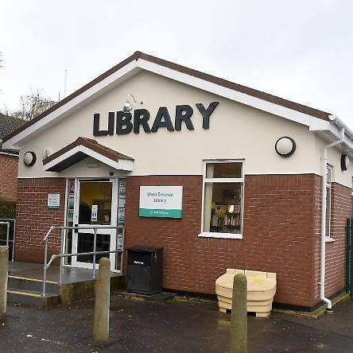
The Friends of Wash Common Library - a charity set up by a group of people from the local community - has been working to re-open the library which was closed in March 2017. We’ve made some progress but we are now at a crunch point.
We need the support of everyone who cares about having a local library in Wash Common to join us and come forward. West Berkshire Council has made it clear that they cannot give any financial assistance to the library. Obtaining the building from the council is a complicated process. However, if we can show that the community here is committed and can raise enough money, this will convince West Berkshire Council to support us.
The new Wash Common Library will be an independent community library, which will be completely self-funded and run by volunteers.
Our aim is to re-open the library in 2018
For us to obtain the library building we need to prove to West Berkshire Council, Newbury Town Council and Fund givers such as Greenham Trust that not only can we finance the re-opening of the library, but we can provide forward financing for the next 3 – 5 years. We need to show we can generate income every year going forward and that we are committed to this for the long term. One way of doing this is for households to pledge to donate a small sum annually – will you be one of the 150 we need to make this happen? We also need individuals to help with volunteering and fundraising. Can you help?

